**NOTICE!!! DON’T USE PROGRAM IN WEB, ONLY LOCAL**

**Introduction**

1. Download the platform 1c (8.3) distribution kit from <https://releases.1c.ru/total>
2. Install 1C platform

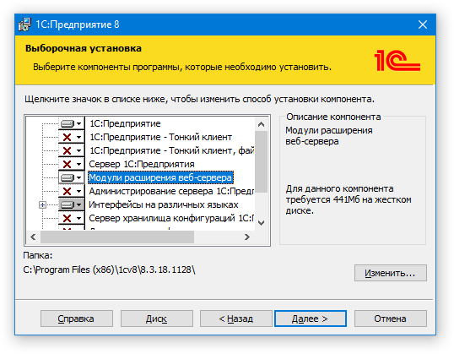

1. Create local 1c database
2. Click «download information base» and choose *.dt file on your computer

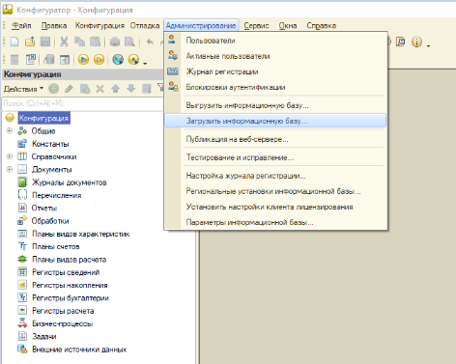



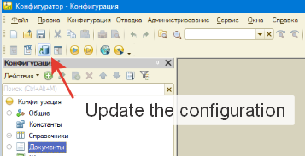

**Functionality**

**Notice: login: admin, pass:1; login: test, pass:1**

1. When you login as **Admin**:
   1. The home page contains a list of orders and associated invoices

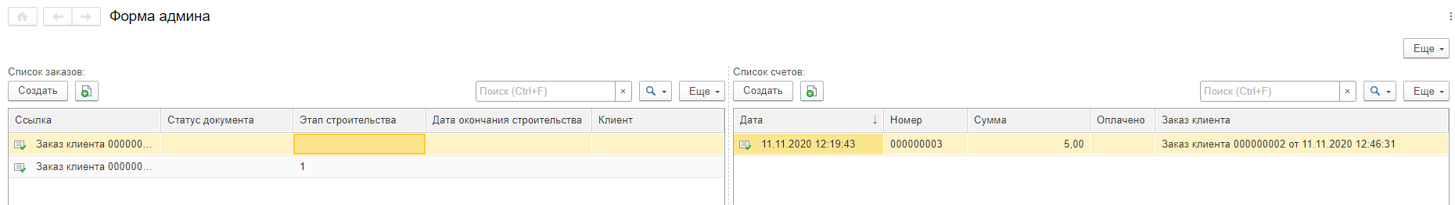

* 1. There admin can upload photos of the construction process, change status of the construction, link customer payments

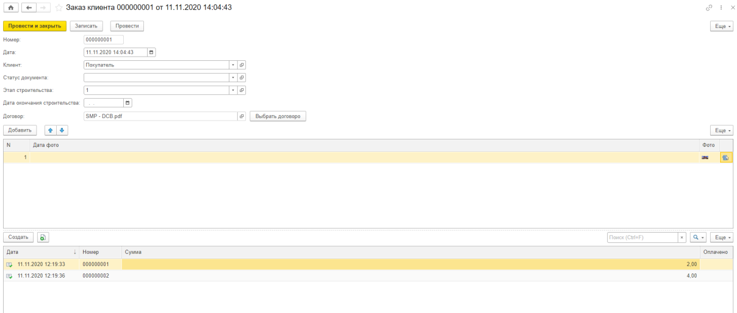

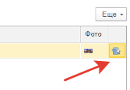

By clicking this button, admin can upload photo

1. When you login as **Buyer**:
   1. There client choose order and see status of construction, photos showing current or previous statuses of construction

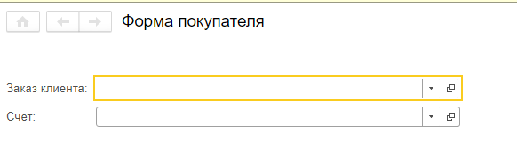

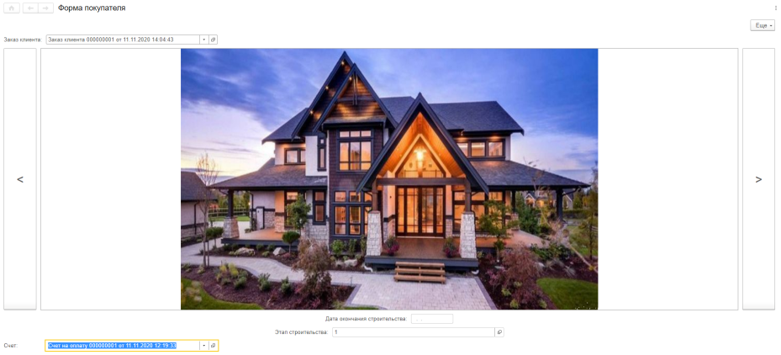

1. To add buyer or admin, you should open form «Users» and add a new user with role (Admin or Buyer) and password

**Payments**

**Notices**: 1) Limits of payments – 15000 RUB

2) Test card – 5555555555554444, month, cardholder and cvc - any

1. To pay non-cash client should click on the following button:

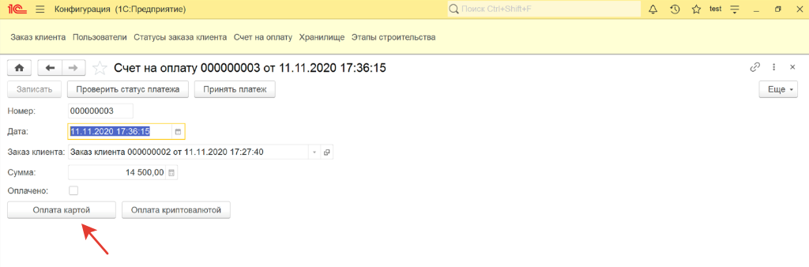

After this client will get the payment link via email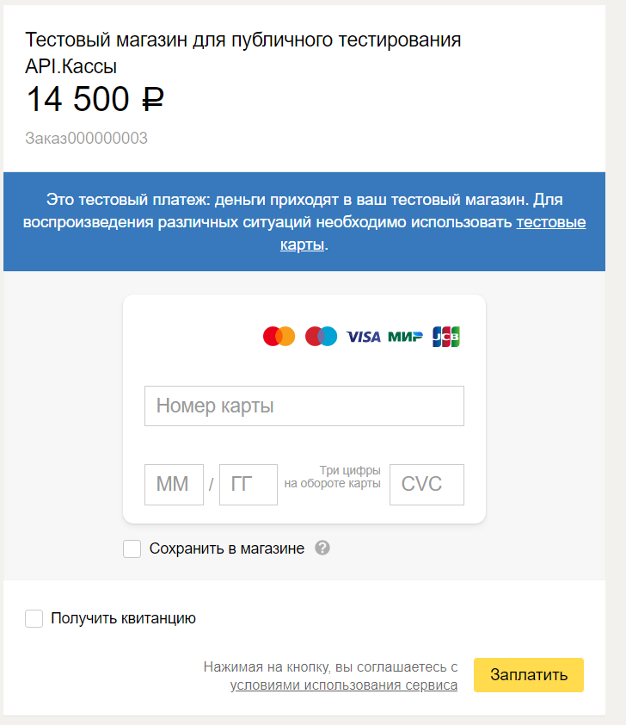

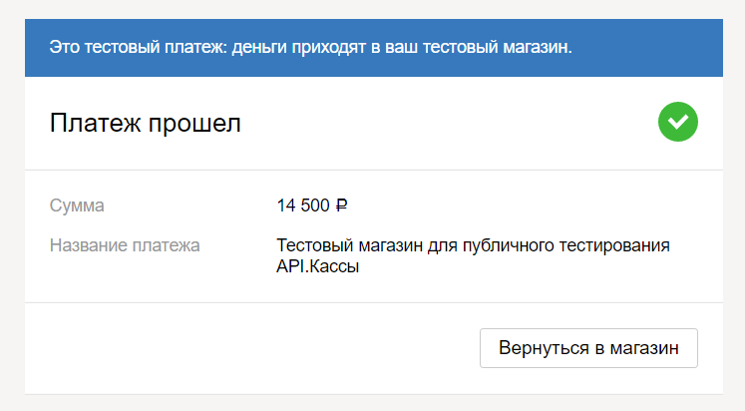

1. After that admin should click on the following button

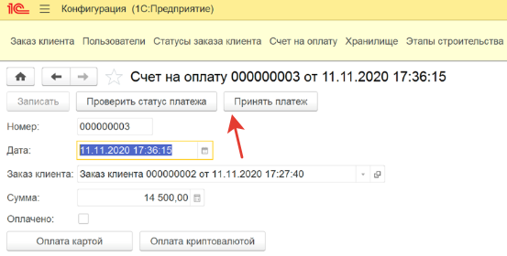

And if the status on the bottom of document = «**waiting_for_capture**», it’s OK.

1. To pay client should click on the following button:

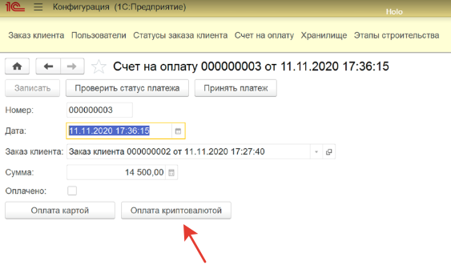

After he will be redirected to following resours:

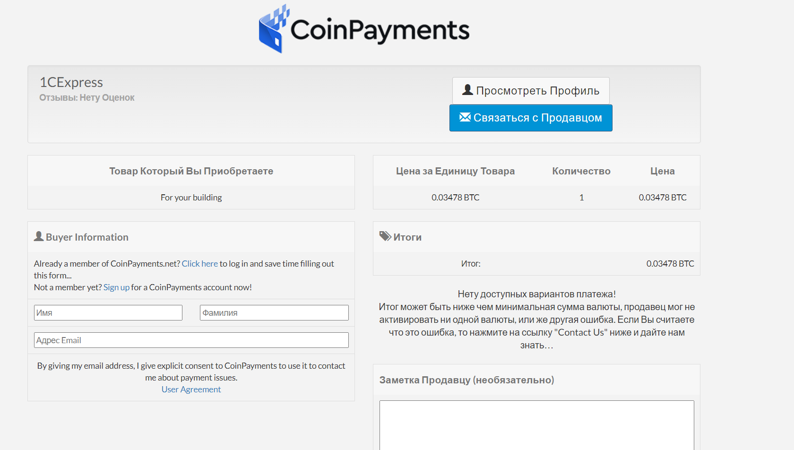

**Electronic signature**

1. Admin choose contract and send it to client

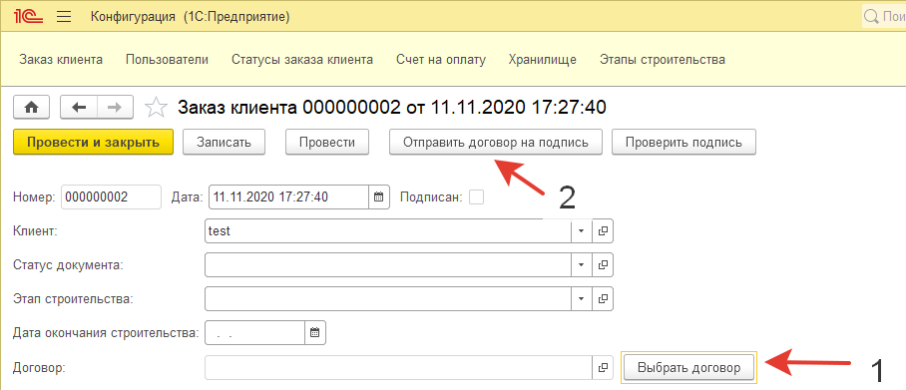

1. Client gets the following email, goes to this website, signs in;

adds signature

